4203201
SOIL MECHANICS
MAKE-UP EXAM
30.12.2013

Student Name:
Q.1 | Q.2 | Q.3 | Q.4 | Q.5 | TOTAL
Number:
Group:

- Provide brief answers to the following questions:

a) Draw the failure envelope for the Mohr-Coulomb theory. Write down the equation for the failure envelope and explain the terms in the equation.
b) What is capillarity? What is its importance in Civil Engineering?
c) Explain the concept of effective stress.
d) Write the meaning of the symbols given below.

- SP:

- CH:

- I_{p} (PI):

- c_{u}:

- A sample from a saturated clayey layer has a total mass of 1580 gr and a dry mass of 1350. Its specific gravity is measured to be G_{s} = 2.70. Determine the water content, void ratio, porosity, dry unit weight, and moist unit weight for this soil.

- Given below is a flow net for water seepage through an earth dam. The hydraulic conductivity (permeability) of the soil is k = 1.4x10⁻⁴ cm/s.

- Calculate the amount of water seepage per unit length of the dam.
- Calculate the water pressures at points A, B, and C assuming a unit weight of water γ_{w} = 9.81 kN/m³.

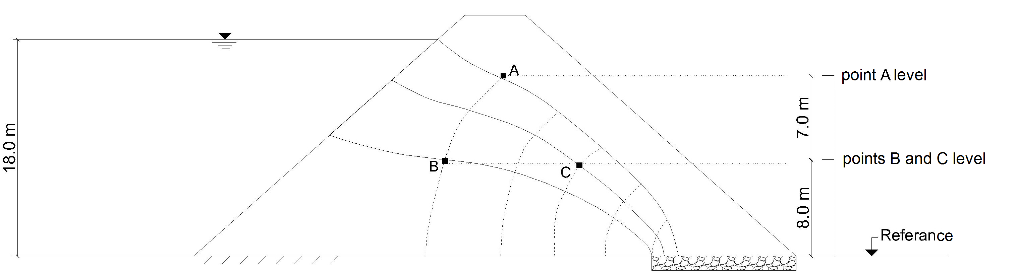
Reference

- A building which has 20 m x 20 m mat foundation will be constructed on a soil with the given profile as shown below.

  - Compute the primary consolidation settlement that will take place underneath the center of the foundation. ( Calculate the stress increase using the Boussinesq method with charts.)
  - Determine the time required for 50% consolidation to take place in the field.

U(%) | 10 | 20 | 30 | 40 | 50 | 60 | 70 | 80 | 90
T | 0,008 | 0,031 | 0,071 | 0,126 | 0,197 | 0,287 | 0,403 | 0,567 | 0,848
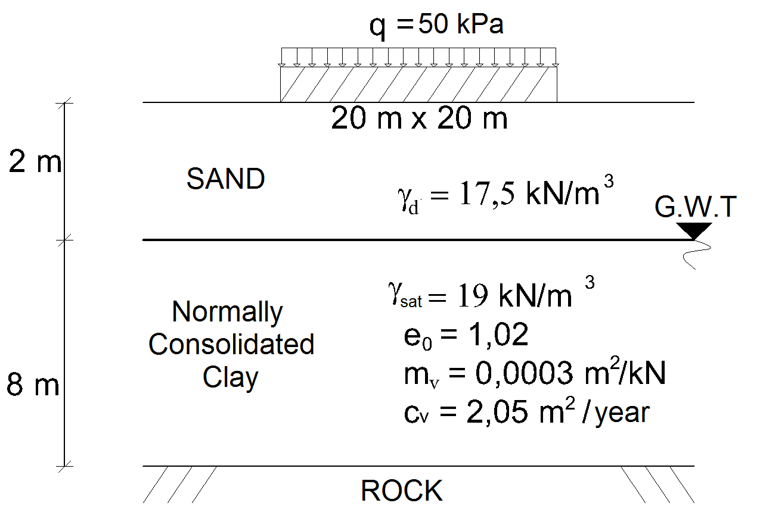

- A consolidated- drained (CD) triaxial test was performed on a normally consolidated clay sample and failure took place when the principal stress difference reached a value of 167 kPa. If the cell pressure applied during the test was 90 kPa;

  - Compute the drained shear strength parameters for the soil sample.
  - Compute the angle that the failure plane makes with respect to horizontal.

Exam time is 90 minutes. Good luck…

